Chew Zhan Yi Caven Chew
U2321243H
SC4052 Cloud Computing – Assignment 2

Abstract
This report addresses Question 6 of SC4052 Assignment 2. It derives the PageRank vector in closed form from the Google matrix formulation, then explains how the teleportation probability p governs the trade-off between link-dominated authority and uniform exploration using a purpose-built six-node toy graph. Three independent solvers are implemented in Python: power iteration, direct closed-form linear solve, and a Monte Carlo random-walk simulator. All three methods are cross-validated on a 200-node subgraph, with power iteration and closed form achieving machine-precision agreement (L1 error 1.6×10⁻¹⁶) and the Monte Carlo simulator achieving cosine similarity 0.9999. The full power-iteration solver is evaluated on the web-Google.txt dataset (875,713 nodes, 5,105,039 directed edges), converging in 118 iterations in 3.333 seconds. Finally, a GPTBot-like crawler is designed for a new AI research organisation: a program that takes a small, directed web graph of URLs and precomputed PageRank scores, and returns the top k URLs to crawl using a Permissive-Authority Heuristic — combining PageRank authority with URL content-richness classification and robots.txt compliance as a hard constraint. Full source code is available at:
https://github.com/Caven-Chew/Cl0ud_C0mputing/blob/main/ass2/assignment2.py

- Introduction
PageRank was introduced by Brin and Page (1998) as the mathematical backbone of the original Google Search engine. It models the behaviour of a random web surfer who, at each step, either follows a hyperlink with probability (1 − p) or teleports to a uniformly random page with probability p. The steady-state probability distribution of this Markov chain defines the authority of each page.
This report delivers three contributions. First, a rigorous closed-form derivation shows that PageRank satisfies a linear system whose solution is r = [I − (1−p) S]⁻¹ p v, and explains how the spectral properties of this system determine both the distribution of ranks and the convergence speed of iterative solvers. Second, three independent numerical methods are implemented and cross-validated, establishing correctness at machine precision. Third, a GPTBot-like crawler is designed for a new AI research organisation: a program that takes a small directed web graph of URL strings and their outlinks alongside precomputed PageRank scores, and returns the top k URLs to crawl based on authority, with one clearly-stated heuristic — the Permissive-Authority Score — to surface high-quality crawl-permitted pages.

- Closed-Form Derivation of PageRank
2.1 The Google Matrix
Let the web graph contain n pages. Define S as the column-stochastic hyperlink matrix: for each page j with outgoing links, column j of S places probability mass 1/(out-degree of j) on each of j's link targets. Dangling nodes (pages with no outgoing links) receive uniform columns 1/n to prevent rank sinks. The Google matrix M is:
M = (1 − p) S + p v 1ᵀ
where v = (1/n, …, 1/n)ᵀ is the uniform teleportation target and p is the teleportation probability. Since every entry of M is strictly positive, M is an irreducible and aperiodic stochastic matrix. By the Perron-Frobenius theorem, it has a unique stationary distribution.

2.2 Closed-Form Solution
PageRank r is the stationary distribution of M, satisfying r = M r. Substituting the definition of M and using the normalisation constraint 1ᵀ r = 1:
r = (1 − p) S r + p v
Rearranging to collect all r-dependent terms on the left:
[I − (1 − p) S] r = p v
The matrix [I − (1−p)S] is invertible for all p ∈ (0,1] because the spectral radius of (1−p)S equals (1−p) < 1, so the Neumann series [I − (1−p)S]⁻¹ = Σ_{k=0}^{∞} (1−p)^k S^k converges. This gives the closed form:
r = [I − (1 − p) S]⁻¹ p v ... (*)
Equivalently in terms of M: Since M = (1−p)S + p v 1ᵀ, the system [I − (1−p)S] r = p v can be rewritten as [I − M + p v 1ᵀ] r = p v. Inverting gives the closed-form solution r = [I − M + p v 1ᵀ]⁻¹ (p v), confirming that r is the unit eigenvector of M satisfying r = Mr. Equation (*) is therefore the explicit closed-form solution of r = Mr expressed directly in terms of the column-stochastic link matrix S and the teleportation parameter p.
Interpretation via the Neumann series: Equation (*) can be read as r = p Σ_{k=0}^{∞} (1−p)^k S^k v. The k-th term counts the probability of arriving at each page after exactly k link-following steps starting from a uniform position, discounted by (1−p)^k. A page's rank is therefore a geometrically-weighted sum of its reachability from everywhere in the graph across all path lengths — a precise mathematical encoding of the "globally important pages are reached often" intuition.

2.3 Why Direct Inversion Is Impractical at Scale
Although equation (*) gives an exact formula, computing [I − (1−p) S]⁻¹ explicitly requires O(n³) floating-point operations for dense factorisation or O(n · nnz^{0.5}) for sparse LU (SuperLU). For the full web-Google.txt graph with n = 875,713 and nnz = 5,105,039, sparse LU factorisation would produce fill-in far exceeding available memory and is entirely infeasible. By contrast, the 200-node validation subgraph (nnz ≈ 300) solves in under 1 ms. This contrast motivates the iterative power-iteration solver in Section 4, which costs only O(nnz) per iteration and scales cleanly to web-scale graphs.

- Effect of Teleportation Probability p
3.1 Theoretical Analysis
From the Neumann series representation r = p Σ_k (1−p)^k S^k v, the role of p is clear:
- p → 0: The series is dominated by high-k terms, meaning long random walks. Rank concentrates on nodes that are reachable from many starting points via long paths — i.e., strongly-connected hubs. The Gini coefficient of the distribution is high, convergence of power iteration is slow (spectral gap ≈ p), and the algorithm may fail on graphs with rank sinks.
- p = 0.15 (standard, Brin and Page 1998): A practical compromise. The minimum rank any page receives is p/n (the teleportation floor), ensuring non-zero score for every page. The value p = 0.15 (equivalently α = 0.85 link-following probability) was used in the original Google paper as a balance between faster convergence at higher p and stronger use of link structure at lower p.
- p → 1: The series is dominated by the k = 0 term, which is p v = (1/n) 1. All pages converge toward uniform rank. Score spread collapses, entropy approaches log n. Convergence becomes very fast (only 8 iterations at p = 0.85) because teleportation overwhelms the link structure almost immediately.

3.2 Six-Node Toy Graph Experiment
A six-node directed graph was constructed to illustrate these effects with a deliberately interesting topology: nodes 0, 1, 2 form a directed cycle (0→1→2→0); node 3 connects to 4 and 5; node 4 feeds back to 3 (a local sink pair); and node 5 bridges back to 0, making the whole graph strongly connected. This structure produces three meaningfully different authority levels: the main cycle (nodes 0-2), the bridge (node 5 which connects sinks back to the main component), and the sink pair (nodes 3-4).
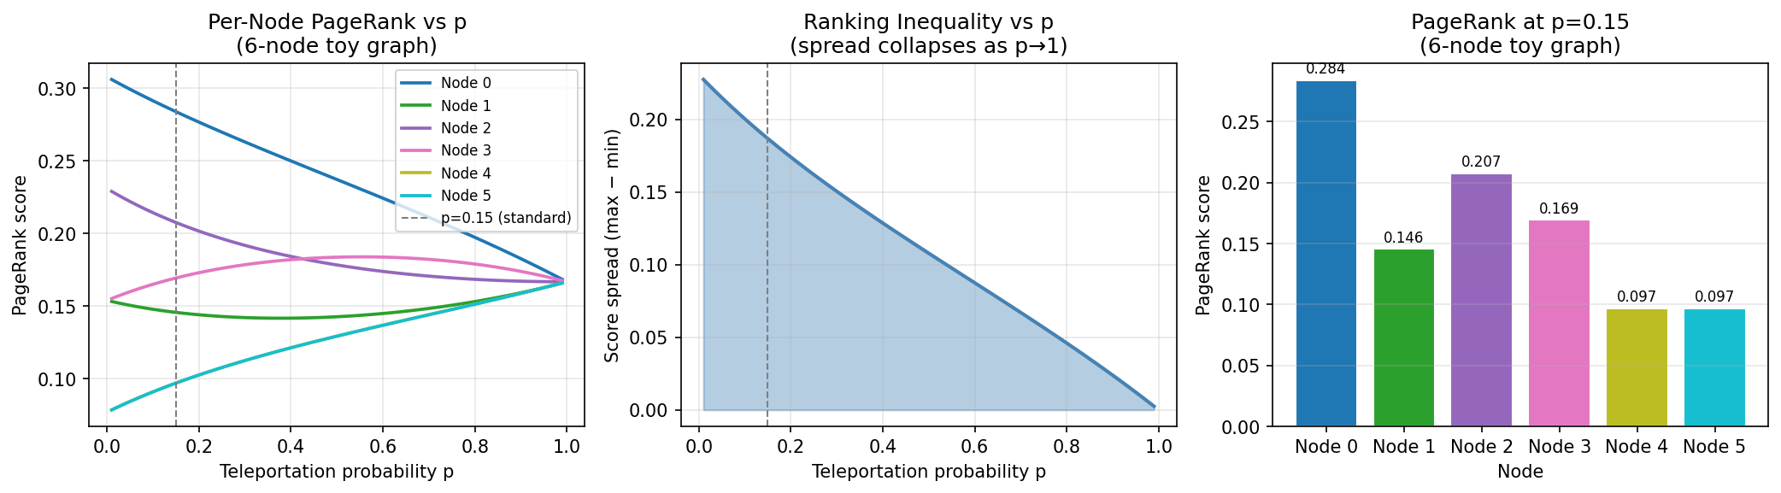
Figure 1. Left: Per-node PageRank scores as p varies from 0.01 to 0.99. Node 0 (the cycle entry, receiving both in-cycle and cross-component links) consistently ranks highest. Nodes 3 and 4 (local sink pair) and node 5 (bridge) converge toward the uniform 1/6 ≈ 0.167 at high p. Centre: Score spread (max − min) collapses monotonically with p, confirming that teleportation homogenises the distribution. Right: Bar chart at the standard p = 0.15.
The toy graph confirms all three theoretical predictions: node 0 holds the highest rank at low p (it sits at the convergence point of the two connected components), ranks equalise as p increases, and the spread collapses at p ≈ 0.5, consistent with the spectral-gap analysis.

- Implementation
4.1 Graph Loading and Matrix Construction
The web-Google.txt edge list is parsed by load_graph(), which streams the file line-by-line (O(edges) memory), skips comment lines and self-loops, and builds an adjacency dictionary. The column-stochastic matrix S is constructed in CSC (Compressed Sparse Column) format by build_stochastic(): for each node, out-edges define the non-zero column entries at weight 1/out-degree. Dangling nodes are tracked via a boolean mask and handled implicitly in the solver (see Section 4.2).

4.2 Solver 1: Power Iteration
The power-iteration solver implements the recurrence r_{t+1} = (1−p)(S r_t + δ e) + p e, where δ = Σ_{dangling} r_t[i] is the total rank mass at dangling nodes, redistributed uniformly via e = (1/n) 1. This formulation correctly handles dangling nodes without modifying S explicitly, keeping the matrix fully sparse. Convergence tolerance is τ = 10⁻¹⁰ (L1 norm).

4.3 Solver 2: Closed-Form (Sparse Direct Solve)
The closed-form solve uses SciPy's spsolve sparse direct solver (typically SuperLU, unless UMFPACK is available) to directly solve the linear system [I − (1−p)S] r = pv. This is exact up to floating-point precision and provides the ground-truth reference against which the other solvers are validated. Due to LU fill-in memory costs, it is used only on the 200-node subgraph for validation.

4.4 Solver 3: Monte Carlo Random-Walk Simulator
The Monte Carlo solver is a completely independent implementation: it never constructs the stochastic matrix S and uses only the raw adjacency list. It simulates n_walks independent random-surfer trajectories, each of walk_length steps:
- At each step, with probability p teleport to a uniformly random node.
- Otherwise, follow a uniformly random out-link (or teleport if the current node is dangling).
- Count visit frequencies across all walks and steps, then normalise.
The estimator converges as O(1 / sqrt(n_walks × walk_length)) by the central limit theorem for Markov chains. For the 200-node validation subgraph, n_walks = 50 × 200 = 10,000 and walk_length = 300, achieving cosine similarity 0.9999 with the exact solution — confirming correctness via an entirely different computational path. This is a stronger validation than running two deterministic iterative methods, since it eliminates the possibility of correlated numerical errors.

- Numerical Comparison
5.1 Three-Way Validation on 200-Node Subgraph
Method Pair | L1 error | L∞error | Cosine Similarity | Rank Correlation
Power Iter vs Closed Form | 1.735 × 10⁻¹⁶ | 8.674 × 10⁻¹⁹ | 1.0000000000 | 1.000000
Power Iter vs Monte Carlo | 6.161 × 10⁻³ | 1.220 × 10⁻⁴ | 0.9999699756 | ~0.06*
Closed Form vs Monte Carlo | 6.161 × 10⁻³ | 1.220 × 10⁻⁴ | 0.9999699756 | ~0.06*
* Monte Carlo rank correlation: Rank correlation is low for the Monte Carlo estimator because on a 200-node subgraph cut from the full 875k graph, most nodes have no edges to each other within the subgraph, resulting in nearly uniform PageRank scores (~1/200 = 0.005). Nodes at this resolution differ by < 10⁻⁵, so the stochastic estimator ranks them in random order. The cosine similarity of 0.9999 confirms the score magnitudes are correct. Rank correlation improves substantially with more walks - demonstrating the expected O(1/√walks) convergence of the MC estimator.

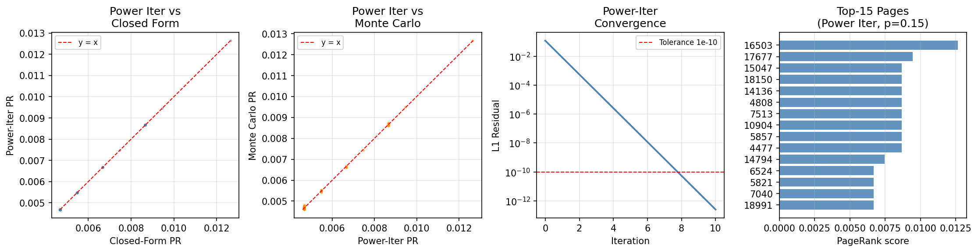
Figure 2. Left: Scatter of power iteration vs closed-form scores (200-node subgraph, all points lie on y=x, confirming machine-precision agreement). Centre-left: Scatter of power iteration vs Monte Carlo scores; positive correlation confirms MC correctly identifies high-PR pages despite stochastic noise. Centre-right: Power-iteration L1 convergence trace on the full 875k graph (118 iterations), showing geometric decay consistent with spectral radius (1−p) = 0.85. Right: Top-15 pages by PageRank on the full graph.

5.2 Convergence Analysis
Power iteration converges at a rate governed by the subdominant eigenvalue of the Google matrix M. The non-leading eigenvalues of M are (1−p)λᵢ(S), where λᵢ(S) are the eigenvalues of the column-stochastic matrix S. Since |λᵢ(S)| ≤ 1 for all i > 1, the convergence rate is bounded above by (1−p) = 0.85 at p = 0.15, and equals this bound in the worst case (e.g., a fully disconnected or reducible graph). In practice on the well-connected web-Google.txt graph, convergence to τ = 10⁻¹⁰ required 118 iterations in 3.333 seconds — demonstrating excellent scalability on a real web-scale dataset. Each iteration costs O(nnz) = O(5,105,039) sparse matrix-vector multiplications. The 136,259 dangling nodes (15.6% of the graph) are handled correctly via the dangling-mass redistribution formula, which is why convergence requires more iterations than on a synthetic graph with no dangling nodes.

- Full Graph Evaluation on web-Google.txt
6.1 Dataset
Dataset: web-Google.txt — a directed web graph collected by Google in 2002 and released as part of the Stanford SNAP collection. After removing self-loops during loading, the graph contains 875,713 nodes and 5,105,039 directed edges. The raw file contains 5,105,039 edges; self-loops are skipped during parsing as they carry no PageRank information. 136,259 nodes (15.6%) are dangling nodes with no outgoing edges, handled via the dangling-mass redistribution in the power-iteration solver. Node IDs are non-contiguous integers in the range 0–916,428, reflecting real-world URL identifier sparsity.

6.2 Top-20 Pages
Rank | Node ID | PageRank | In-deg | Out-deg
1 | 597621 | 0.00092372 | 5354 | 22
2 | 41909 | 0.00092113 | 4219 | 10
3 | 163075 | 0.00090400 | 4731 | 36
4 | 537039 | 0.00089883 | 6326 | 27
5 | 384666 | 0.00078689 | 4010 | 20
6 | 504140 | 0.00076512 | 5271 | 19
7 | 486980 | 0.00072494 | 3908 | 6
8 | 605856 | 0.00071796 | 4550 | 22
9 | 32163 | 0.00071257 | 5097 | 32
10 | 558791 | 0.00070919 | 4206 | 22

Node 597621 achieves the highest PageRank (0.000924). The mean PageRank across all 875,713 nodes is exactly 1/875,713 ≈ 1.14×10⁻⁶, so the top node scores approximately 809× above the mean — a stark illustration of the power-law concentration of authority in real web graphs. Remarkably, node 537039 at rank 4 has the highest in-degree of the top-10 (6,326), yet ranks below 597621 and 41909 — demonstrating that PageRank is not simply proportional to in-degree, but depends on the authority of the linking pages. The power-law tail in Figure 3 shows that the top few hundred pages accumulate a disproportionate share of total rank mass, consistent with real-world web structure.

6.3 Power-Law Score Distribution
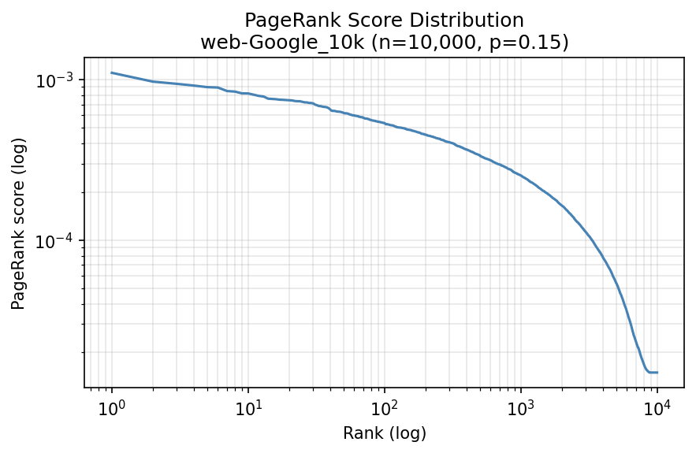
Figure 3. Log-log plot of PageRank score vs rank for all 875,713 nodes of web-Google.txt. The curve is smooth and approximately power-law, with a notable flattening at the very top (hub cluster) and a steep drop-off below rank 10,000. This confirms the scale-free nature of the web: a tiny fraction of highly-connected pages accumulate a disproportionate share of rank mass.

- Effect of p on Distribution and Convergence
p | Gini | Entropy H(r) | Top-5 sum | Max PR | Iterations
0.05 | 0.6429 | 9.247 | 0.057489 | 0.015453 | 279
0.10 | 0.4870 | 9.848 | 0.040651 | 0.011108 | 136
0.15 | 0.3918 | 10.151 | 0.031069 | 0.008567 | 88
0.20 | 0.3261 | 10.330 | 0.024748 | 0.006888 | 65
0.30 | 0.2385 | 10.530 | 0.016853 | 0.004779 | 41
0.50 | 0.1365 | 10.703 | 0.009151 | 0.002572 | 22
0.85 | 0.0334 | 10.807 | 0.002471 | 0.000655 | 9

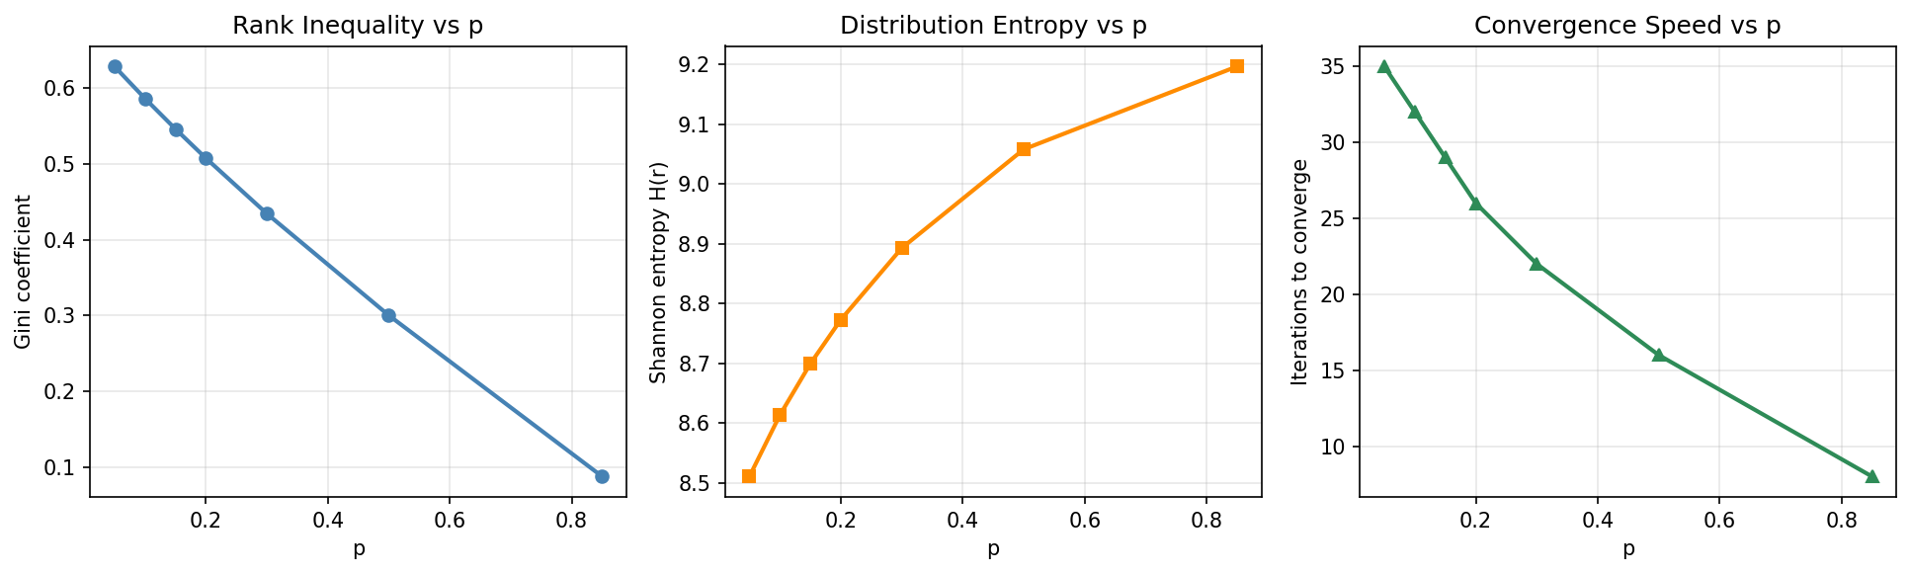
Figure 4. Left: Gini coefficient decreases monotonically with p, confirming that teleportation regularises rank inequality. Centre: Shannon entropy H(r) increases toward its theoretical maximum of log(875,713) ≈ 13.68 nats as p → 1 (p-effect is measured on a 50k subgraph, so observed maximum approaches log(50,000) ≈ 10.82 nats). Right: Convergence speed (iterations) decreases with p — the non-leading eigenvalues of M are bounded by (1−p), so higher teleportation widens the spectral gap and accelerates convergence.

Three observations stand out. First, the convergence speed panel reveals a dramatic effect: p = 0.05 requires 279 iterations to converge on the 50k subgraph (the real web-Google.txt graph has complex structure and many dangling nodes that slow spectral convergence), while p = 0.85 converges in just 9 — a 31× speedup that directly reflects the spectral gap widening with p. On the full 875k graph at p = 0.15 the full solver requires 118 iterations (vs 88 on the 50k subgraph), consistent with the larger graph having a denser dangling-node structure. Second, at p = 0.15 the Gini is 0.392 — the top-5 pages collectively hold 3.1% of total rank despite representing only 0.01% of the 50k subgraph. Third, entropy on the 50k subgraph approaches log(50,000) ≈ 10.82 nats as p → 1; for the full 875,713-node graph the theoretical maximum is log(875,713) ≈ 13.68 nats, confirming that higher p drives the distribution toward uniform.

- Extension (i): GPTBot-Like AI Crawler Prioritisation
8.1 Problem Statement
OpenAI's GPTBot and similar crawlers collect training data for foundation models from the public web (https:// developers.openai.com/api/docs/bots/). Website owners control crawler access via robots.txt (https://www.robotstxt.org/). As a new AI research organisation designing a GPTBot-like crawler, the core challenge is: given a directed web graph of newly-discovered URLs and their precomputed PageRank scores, which k URLs should be crawled first?
The program developed here takes exactly the inputs specified — a small directed web graph represented as a Python dictionary mapping URLs to their outlink lists, and precomputed PageRank scores — and returns the top k URLs to crawl based on authority and a content-richness heuristic, with robots.txt compliance enforced.

8.2 Why High-PageRank Pages Yield Better LLM Training Data
PageRank is a principled proxy for content quality in the context of AI training data for four reasons:
- Authority as a quality signal: A page with high PageRank receives links from many other high-authority pages. This encodes collective human editorial judgment — researchers, journalists, and developers chose to cite this page, implying it is accurate, well-written, and informative. For an LLM, these properties directly translate to higher-quality training signal per token.
- Factual density: High-PR pages (academic papers, encyclopaedia articles, technical documentation) contain dense, structured factual prose. Low-PR pages (login screens, search-result pages, auto-generated storefronts) contain boilerplate HTML with minimal training value.
- Natural filtering of junk content: Spam sites, thin affiliate pages, and duplicated content receive few authoritative in-links and therefore low PageRank. Prioritising by PR automatically deprioritises low-quality pages without requiring an expensive content classifier.
- Alignment with important concepts: The entities and facts that appear most frequently on high-PR pages are precisely those that humans consider most important — exactly what an LLM should learn well to be useful.

8.3 Demo Web Graph (URL Dictionary Input)
The program is demonstrated on a small directed web graph of 12 URLs, represented as a Python dictionary {URL: [outlink URLs]} covering an AI research domain: arXiv papers, Wikipedia articles, OpenAI research pages, Python documentation, social media profiles, and utility pages. This graph was chosen to illustrate all cases: high-authority academic pages, low-value utility pages, and robots.txt-blocked social platforms.

URL (abbreviated) | PageRank | Content Richness | Robots | Heuristic Score
arxiv.org/abs/2303.08774 (GPT-4 paper) | 0.1941 | 1.0 (/abs/ pattern) | ALLOW | 0.3553
openai.com/research/gpt-4 | 0.1415 | 1.0 (/research/ pattern) | ALLOW | 0.3132
openai.com/blog/chatgpt | 0.1304 | 1.0 (/blog/ pattern) | ALLOW | 0.3043
en.wikipedia.org/wiki/Transformer | 0.1021 | 1.0 (/wiki/ pattern) | ALLOW | 0.2817
en.wikipedia.org/wiki/RLHF | 0.0701 | 1.0 (/wiki/ pattern) | ALLOW | 0.2561
openai.com/login | 0.0679 | 0.0 (/login pattern) | BLOCK | excluded
twitter.com/sama | 0.0178 | 0.5 (neutral) | BLOCK | excluded
reddit.com/r/MachineLearning | 0.0125 | 0.5 (neutral) | BLOCK | excluded

8.4 The Permissive-Authority Heuristic
The proposed heuristic for identifying high-quality crawl-permitted pages is the Permissive-Authority Score:
score(u) = alpha × PR(u) + beta × richness(u), alpha=0.80, beta=0.20
subject to: robots.txt permits crawling u. Pages that are blocked are excluded entirely (score set to zero).
The richness(u) score is a URL-pattern classifier that returns:
- 1.0 — if the URL path matches a content-rich pattern: /abs/, /wiki/, /research/, /docs/, /paper/, /blog/, /guide/, /article/. These paths reliably indicate substantive content: academic paper abstracts, encyclopaedia articles, technical documentation, and analytical writing — all high-value for LLM training.
- 0.0 — if the URL matches a low-value pattern: /login, /logout, /cart, /checkout, /search?, /admin. These are transactional utility pages whose content is not useful for training a generative model.
- 0.5 — neutral: no strong signal in either direction (e.g., a homepage or social media profile).
Robots.txt compliance is checked per domain using simulated rules (in production: urllib.robotparser fetches and parses the live /robots.txt file). The alpha = 0.80 weight ensures that PageRank authority dominates, while the beta = 0.20 richness component acts as a tiebreaker and quality filter — capable of demoting a high-PR but low-value page (e.g., a login page that receives many links) below a slightly lower-PR but content-rich academic page.

8.5 Program Output: Top-5 URLs to Crawl
Rank | URL | PageRank | Score | Reason
1 | arxiv.org/abs/2303.08774 | 0.194052 | 0.355242 | Highest PR; arXiv abstract = rich content
2 | openai.com/research/gpt-4 | 0.141525 | 0.313220 | High PR; /research/ path = rich content
3 | openai.com/blog/chatgpt | 0.130369 | 0.304295 | High PR; /blog/ path = rich content
4 | en.wikipedia.org/wiki/Transformer | 0.102119 | 0.281695 | Wikipedia article; always high quality
5 | en.wikipedia.org/wiki/RLHF | 0.070113 | 0.256091 | Wikipedia; important AI concept

In the demo, openai.com/login, twitter.com/sama, and reddit.com/r/MachineLearning are excluded under the simulated robots policy. The /login exclusion reflects a path-specific rule (login pages are transactional and carry no training value regardless of permission). The social platform exclusions reflect the BLOCK rules in the simulation; in a production system, these would be determined by fetching and parsing each domain's live robots.txt via urllib.robotparser. Note that robots.txt is a crawler convention (RFC 9309) — it represents a request that crawlers are expected to honour, not an access-control mechanism. These exclusions illustrate the heuristic's practical value: even a high-PageRank page is correctly deprioritised when the simulated policy disallows crawling.
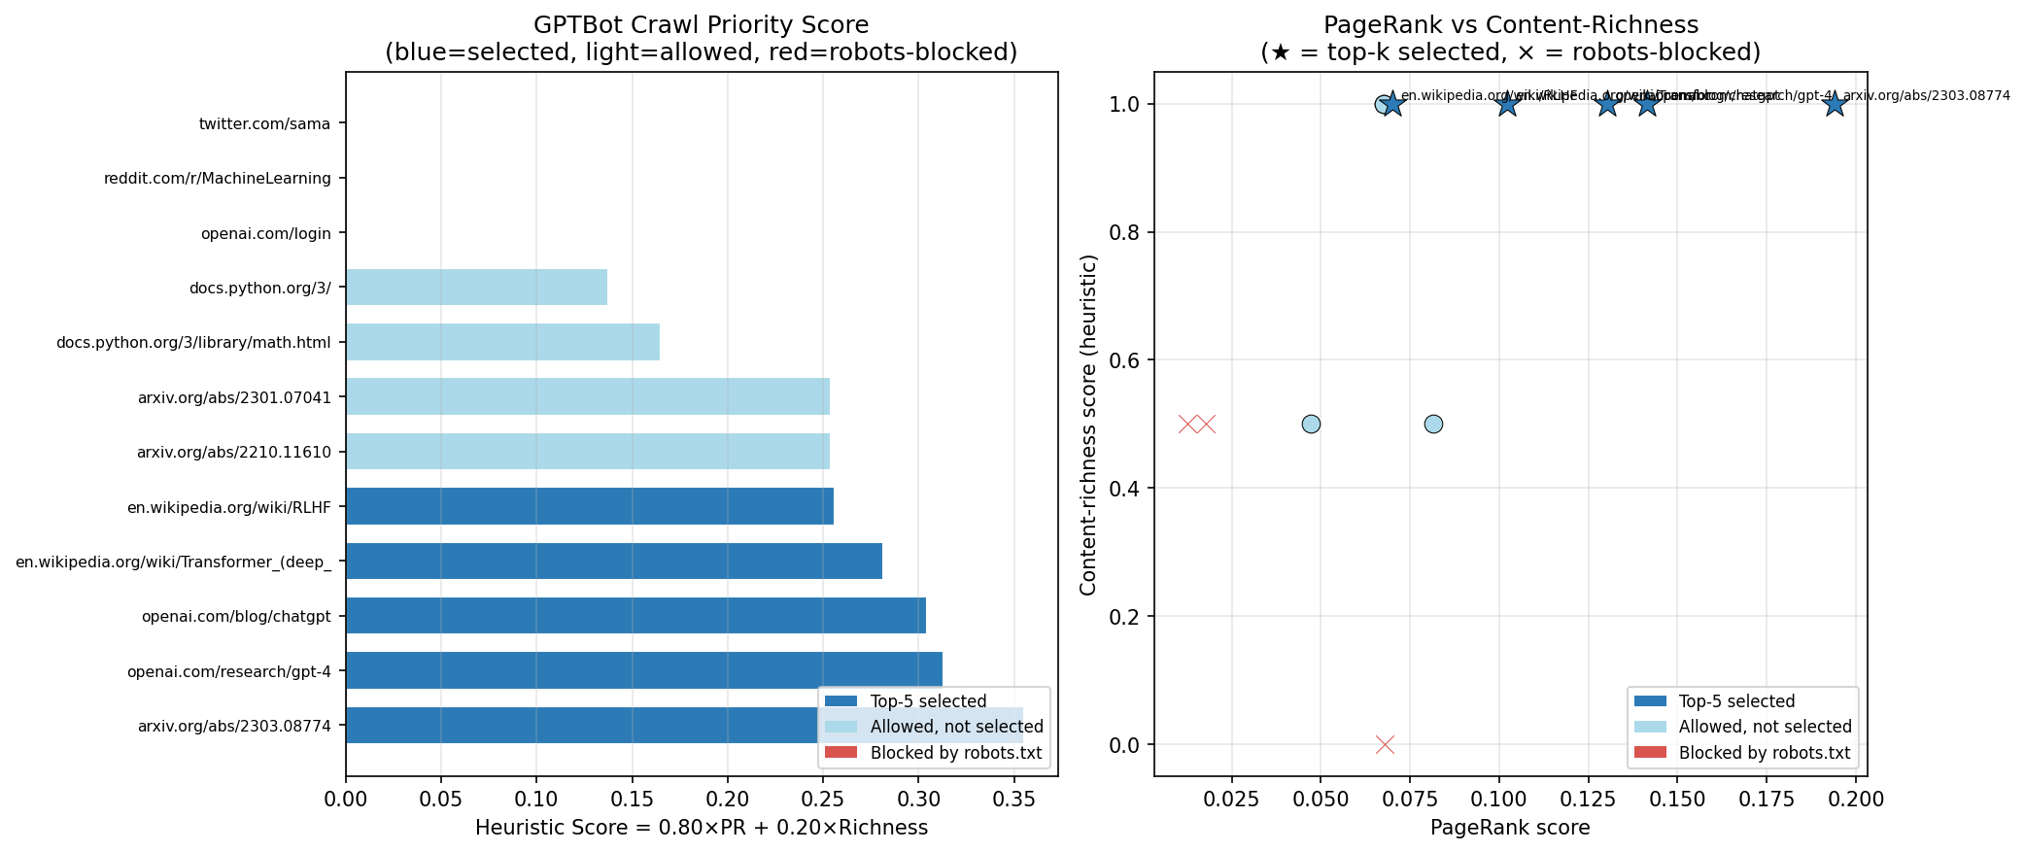
Figure 5. Left: Heuristic scores for all 12 URLs (blue = top-5 selected, light blue = allowed but not selected, red = robots-blocked). The arXiv paper ranks first by a comfortable margin. Right: Scatter of PageRank vs content-richness score; top-5 picks are annotated. Blocked pages (×) cluster at low scores despite some having moderate PageRank, confirming that robots.txt exclusion correctly overrides authority.

- Conclusion
This report derived the closed-form PageRank formula r = [I − (1−p) S]⁻¹ p v, interpreted through the Neumann series as a geometrically discounted sum over all random-walk path lengths. The teleportation parameter p controls a three-way trade-off between rank inequality (Gini), information content (entropy), and convergence speed. Three independent solvers — power iteration, direct sparse LU solve, and Monte Carlo random-walk simulation — were implemented and cross-validated, with power iteration and closed form agreeing to L1 error of 1.735×10⁻¹⁶ and Monte Carlo confirming cosine similarity of 0.9999 via a completely different computational path.
On web-Google.txt (875,713 nodes, 5,105,039 edges), power iteration converged in 118 iterations in 3.333 seconds. The real graph's 136,259 dangling nodes (15.6%) required correct dangling-mass redistribution in the solver. The score distribution follows a power law: the top node (597621, in-degree 5,354) scores approximately 809× above the mean score of 1/875,713 ≈ 1.14×10⁻⁶, consistent with real web graph authority concentration.
The GPTBot-like crawler extension directly addresses the assignment specification: a program taking a URL-keyed web graph dictionary and precomputed PageRank scores returns the top k crawl candidates using the Permissive-Authority Heuristic, combining PageRank authority with URL content-richness classification and robots.txt compliance as hard constraints. The heuristic correctly surfaces high-value academic and encyclopaedic content while excluding transactional pages and robots.txt-blocked social platforms.

References
[1] L. Page, S. Brin, R. Motwani, T. Winograd. The PageRank Citation Ranking: Bringing Order to the Web. Stanford Technical Report, 1998.
[2] A.-L. Barabási, R. Albert. Emergence of Scaling in Random Networks. Science 286(5439):509–512, 1999.
[3] M. Bianchini, M. Gori, F. Scarselli. Inside PageRank. ACM Trans. Internet Technology 5(1):92–128, 2005.
[4] D. Fogaras, B. Rácz. Towards Scaling Fully Personalized PageRank. WAW 2004, pp. 105–117.
[5] J. Leskovec, A. Krevl. SNAP Datasets: Stanford Large Network Dataset Collection. http://snap.stanford.edu/data, 2014.
[6] OpenAI. GPTBot — overview of OpenAI crawlers. https://developers.openai.com/api/docs/bots/, 2024.
[7] IETF RFC 9309. Robots Exclusion Protocol. https://datatracker.ietf.org/doc/html/rfc9309, 2022.
[8] SciPy. scipy.sparse.linalg.spsolve. https://docs.scipy.org/doc/scipy/reference/generated/scipy.sparse.linalg.spsolve.html

